MYSQL – STORED OBJECTS

* Objects that are stored in the database
* E.g. CREATE ...... tables, indexes
* Anything that you do with CREATE command is a sored object

VIEWS :-

* Present in all RDBMS and some of the DBMS
* View is a handle to a table
* Stores the address of the table
* View is a HD pointer (stores the address of the table)

(known as locator)

* Used for indirect access to the table

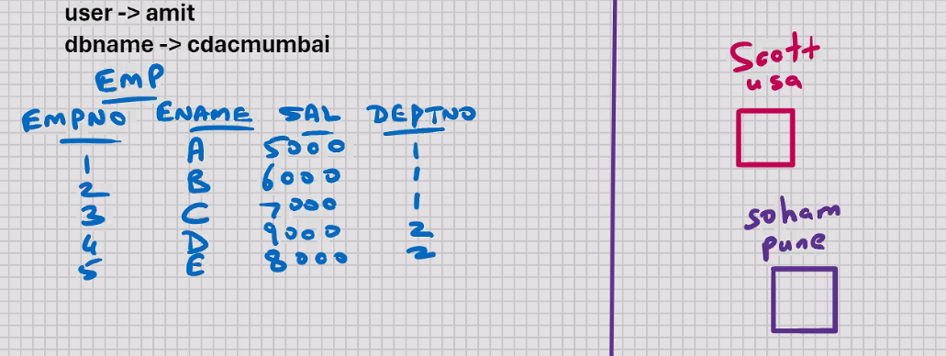

Mysql> create view viewname.........;

Amit_mysql> create view v1

As

Select empno, ename from emp;

View created.

Scott_mysql> select * from cdacmumbai.emp; 🡨 error

Scott_mysql> select * from cdacmumbai.v1;

Root_mysql > grant select, insert on cdacmumbai.v1 to scott@localhost;

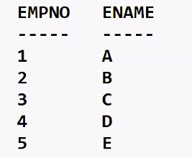

* Used to restrict the column access
* View doesn’t contain data
* Only the definition is stored; data is not stored
* View is a stored query (stored in the database)
* SELECT statement on which the view is based, it is stored in the DB in the compiled format
* View is an executable format of select statement
* Hence the evaluation will be very fast
* Hiding the source code from end user

Scott_mysql > insert into cdacmumbai.v1 values(6, ‘F’);

* DML operations can be performed on a view
* DML operations done on a view will affect the base table
* Constraints that are specified on the table will be enforced even when you insert via the view

Amit_mysql> drop view v1;

Create view v2

As

Select * from emp where deptno = 1;

Select * from v2;

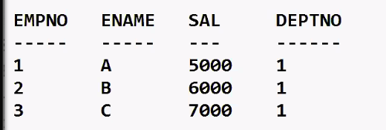

* Used to restrict the row access

18-10-24

Mysql> select * From emp;

* ; is known as delimiter
* It indicates end of command

Mysql > delimiter .

Mysql> select * from emp.

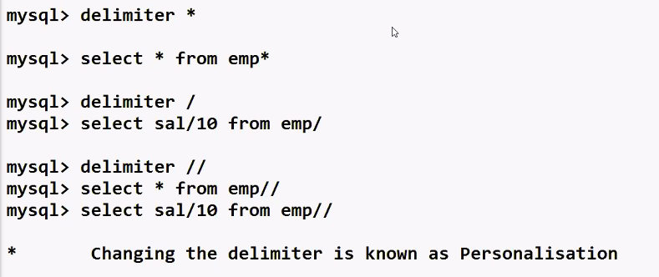

MYSQL – PL

* MYSQL programming language
* Programming language from MYSQL
* Product of MYSQL
* Used for database programming
* E.g. HRA_CALC , TAX_CALC, ATTENDANCE_CAL, etc.
* EVERY RDBMS has its own native programming language :-
* Oracle (PL/SQL) 🡪 procedural language SQL

(most popular language for commercial RDBMS) (63%)

* MS SQL Server (T-SQL) 🡪 transact SQL
* MYSQL (MYSQL - PL) 🡪 MYSQL programming language

(most popular language for open source RDBMS) (42%)

* Used for server side data processing
* MYSQL PL program can be called in MYSQL command line client,

MYSQL workbench, java, MS.net, C++ , etc; can be called through any front-end s/w

* Has few 4 GL features (supports few OOPS features)
* Mysql > call hra_calc();

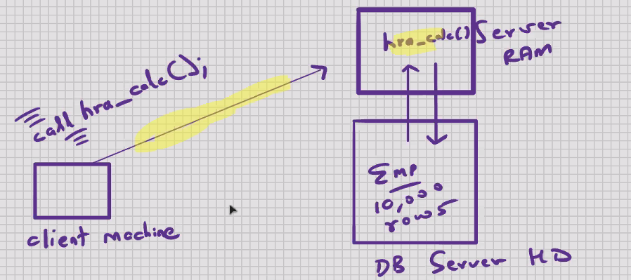

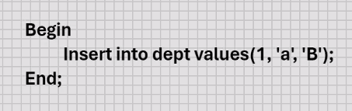

* Mysql -pl program is commonly referred to as a MYSQL- PL block

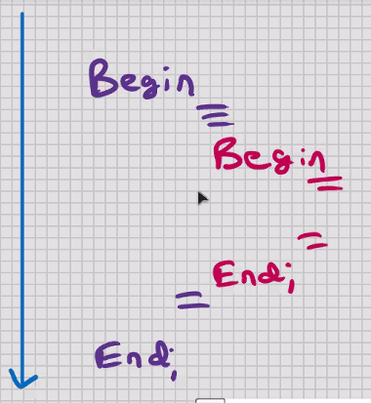 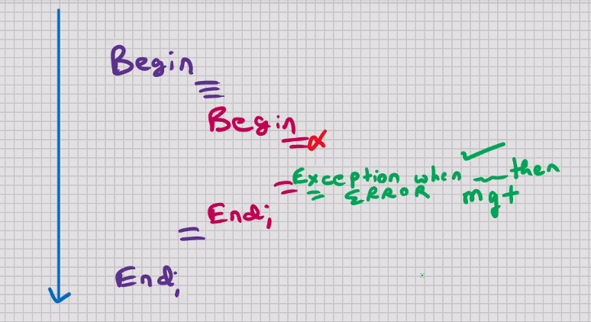

* Block level language because nested blocks are allowed within main block (feature of OOPS)
* Benefits of block level language :-

1. Modularity
2. Control scope of variables (form of data hiding) (Encapsulation)
3. Efficient error management with the help of exceptions

* Screen input and screen output is not allowed (scanf, printf, etc. Not available)
* Used ONLY for processing
* Can use SELECT statement inside the block but it’s not recommended
* SQL commands that are allowed inside MYSQL-PL block :-

DDL, DML, DQL, DTL/TCL

* DCL commands are not allowed inside MYSQL-PL program
* Delete from emp

Where deptno = (select deptno from emp where ename = ‘Thomas’);

To store output of MYSQL – PL Program :-

* Create table tempp  
  (

Fir int,

Sec char(15)

);

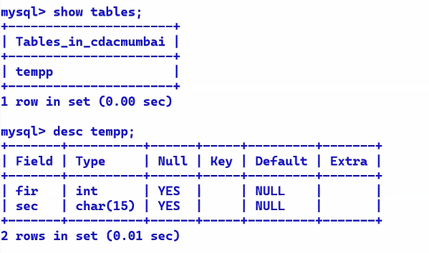

* Mysql – pl programs are written in the form of stored procedures

MYSQL- STORED OBEJECTS

* Objects that are stored in the database
* CREATE ... tables, indexes, views
* Anything that you do with CREATE command is a stored object

STORED PROCEDURES

* Routine (set od commands) that has called explicitly
* Global procedures
* Stored in the database
* Can be called through MYSQL command line client, MYSQL WORKBENCH, java, MS .net , etc ; can be called through any front-end s/w

Mysql > call hra_calc();

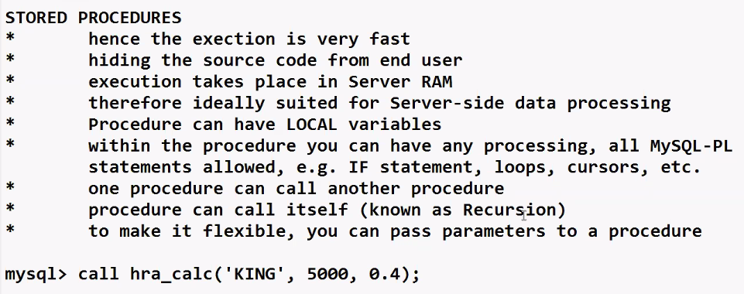

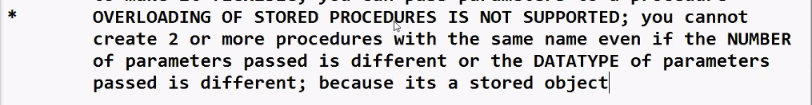

Starting of programming language

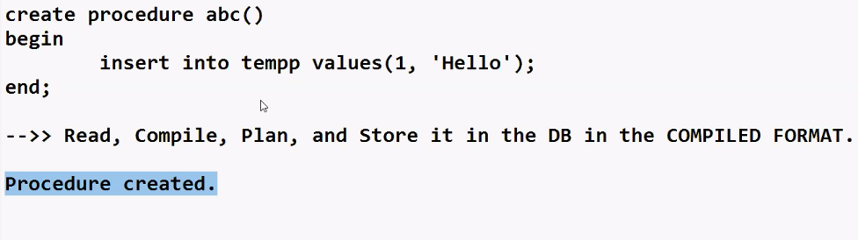

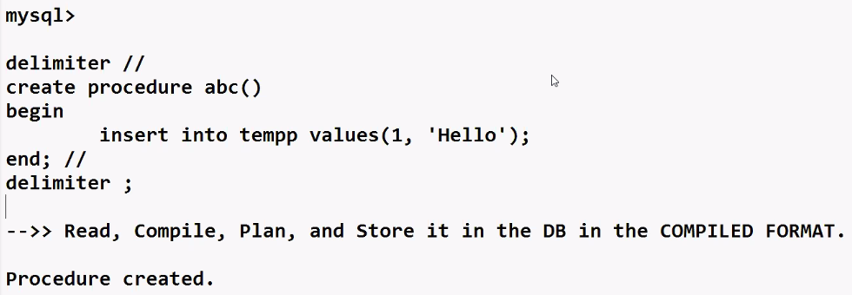

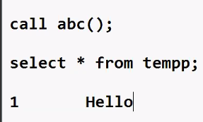

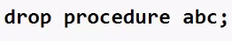

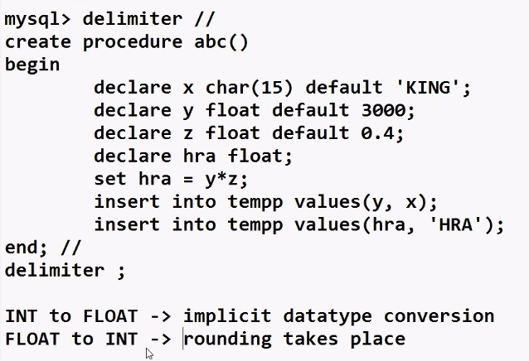

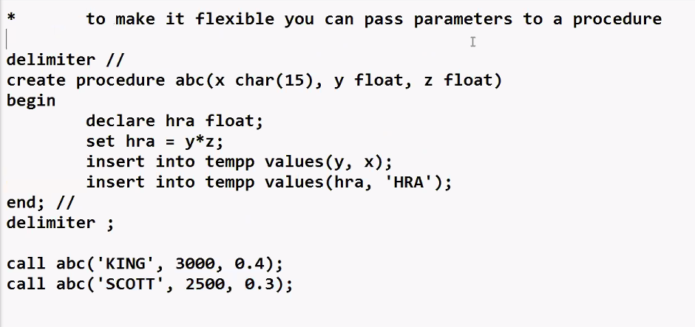

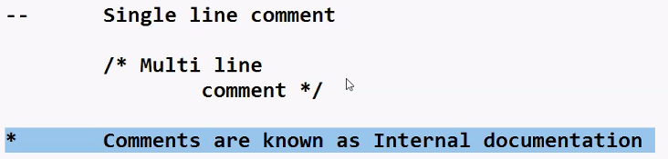



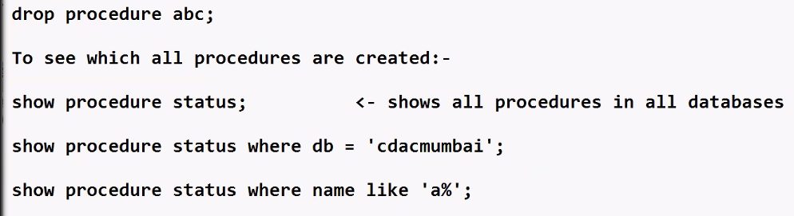

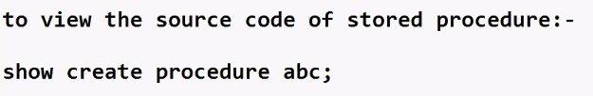

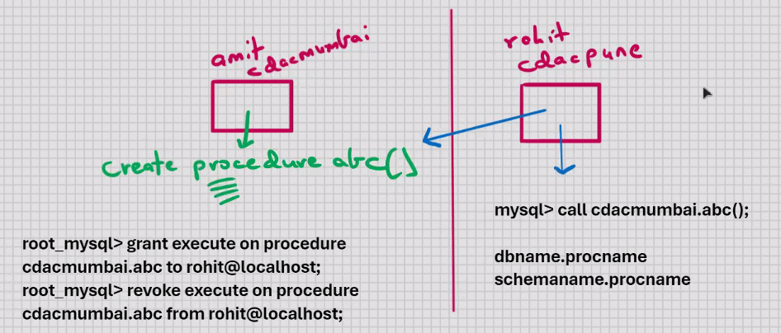

Topics we covered before break :-

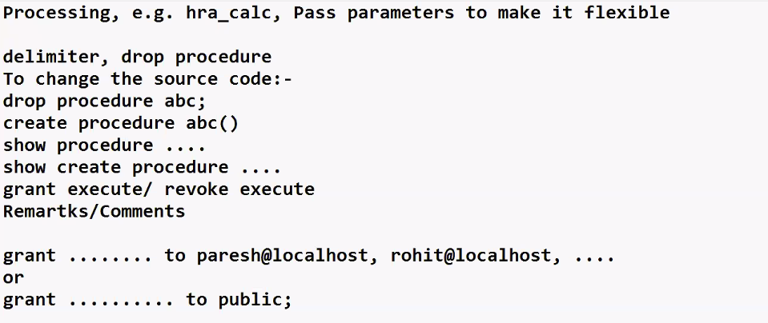

After break :-

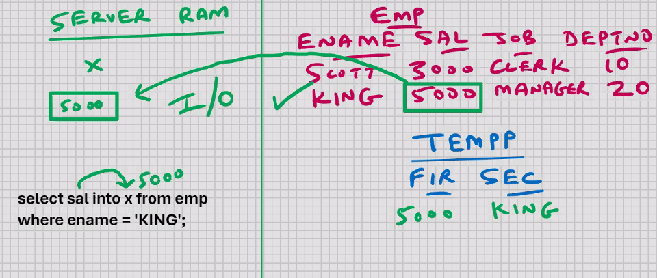

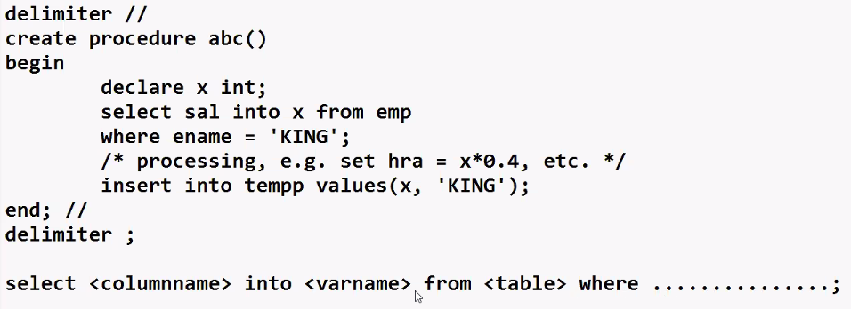

X and sal should be of same datatype otherwise there will be vulnerability

Ensure that king is present in the table

Ensure that only one king is present in the table

To make the above program flexible we can use parameters :-

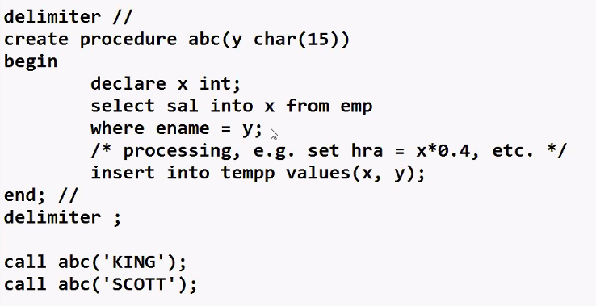



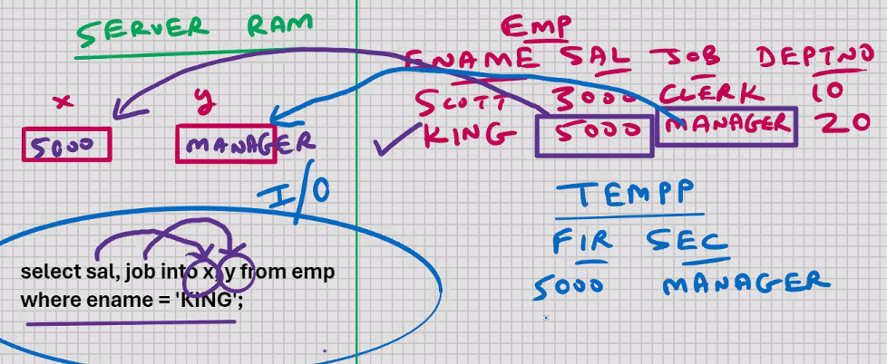

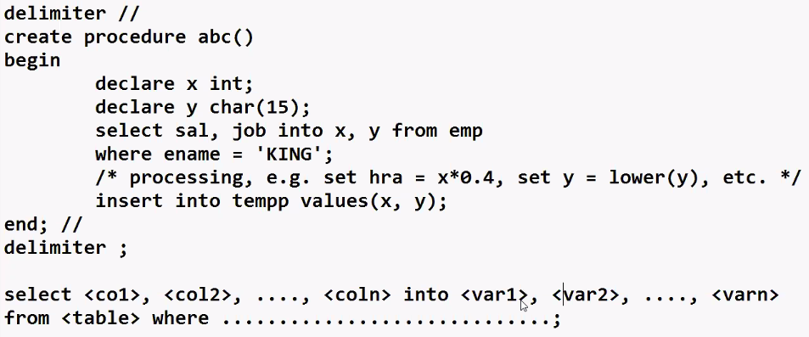

* Datatype of x and sal, y and job should be same
* King should be present in the table
* Only one row of king should be present in the table
* Decision making using IF statement 🡪

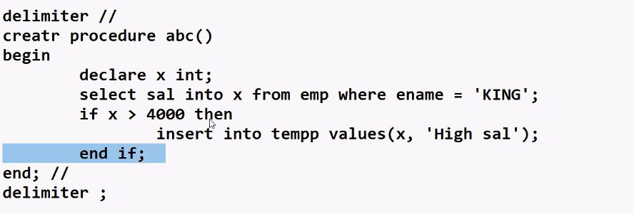

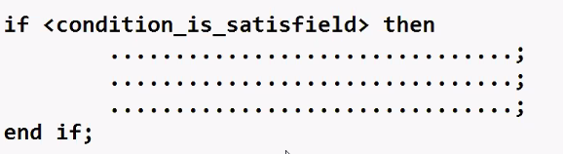

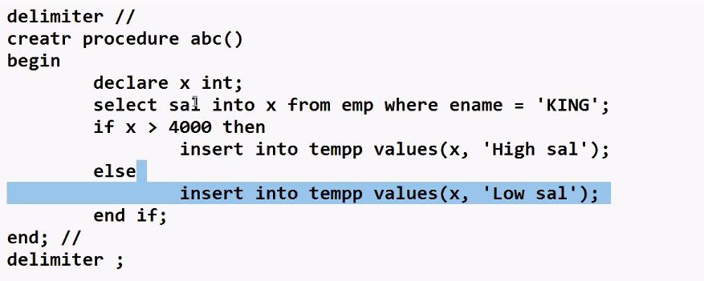

Else is optional if we didn’t specify the else then results into nothing

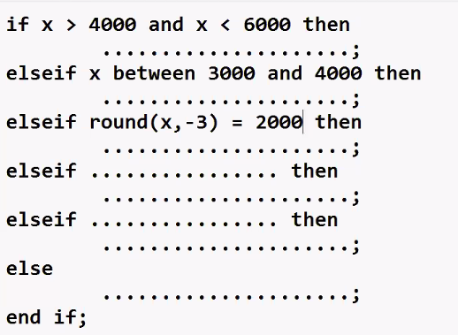

Boolean in IF statement :-

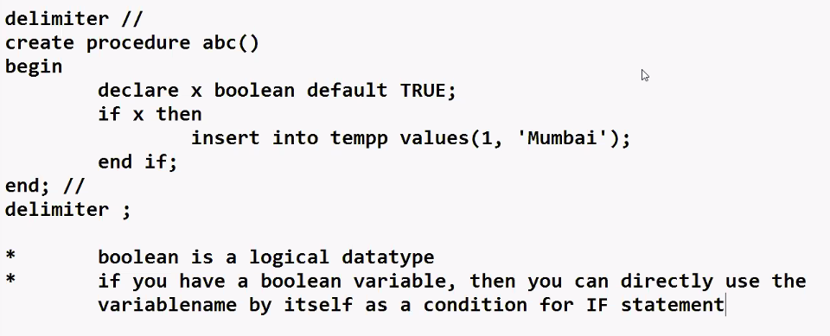

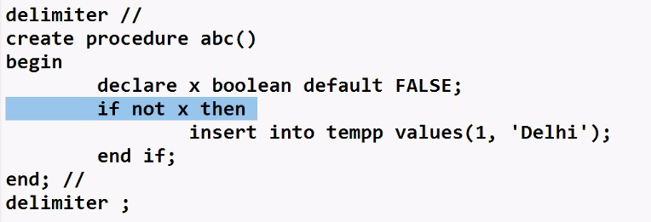

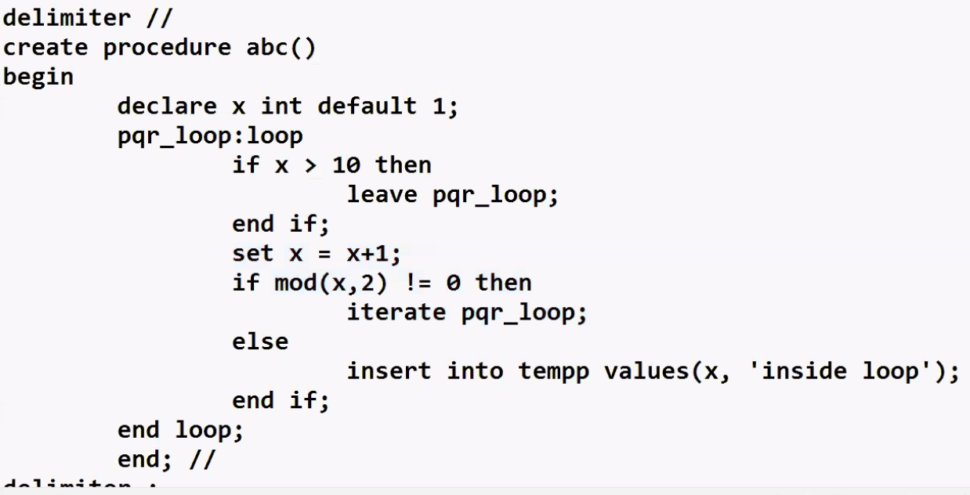

MYSQL – CURSORS ( VVV.IMP) :-

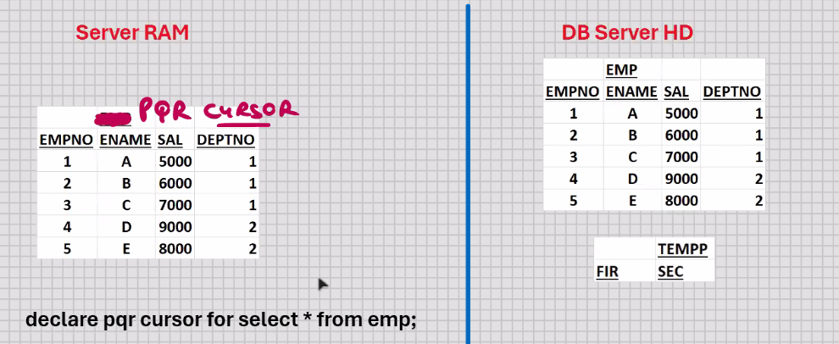

DB SERVER HD

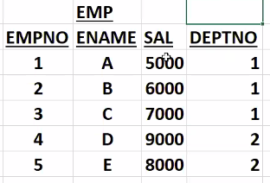

Empno int

Ename varchar (15)

Sal int

Delt int

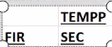

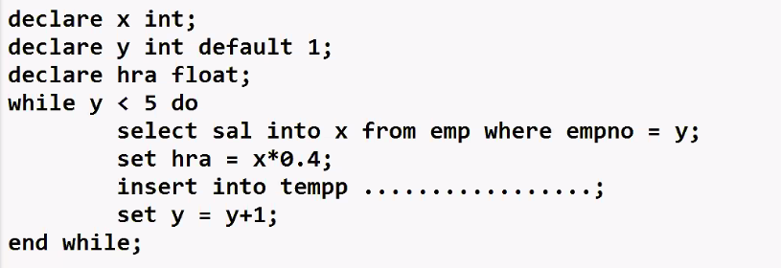

* Cursors are present in all RDBMS, some DBMS also, and some of the front-end s/w
* Cursor is a type of a variable
* Cursor can store multiple rows
* Cursors is similar to 2D array
* Used for processing multiple rows
* Used for storing multiple rows
* Used for handling multiple rows
* Used for storing the data temporarily
* Cursor has to be declared after all the variables
* Cursor is based on SELECT statement (also cursor can contains only those rows and column for which you want to do processing) we can use orderby , group by, can contain join, subqueries, views
* The select statement on which the cursor is based could be anything, e.g. select col1, col2, .....coln, where clause, ORDER by clause , HAVING clause, GROUP BY clause
* You can have cursors based on join , sub-queries, set operators, view, etc
* You can have cursor based on computed column, expression , function etc
* Cursor is a READ _ONLY variable
* Data that is present inside the cursor, it cannot be manipulated
* You will have to fetch 1 row at a time into some intermediate variables, and do your processing with those variables
* You can only fetch sequentially ( top to bottom )
* You cannot fetch backwards in MySQL CURSOR
* You can inly fetch 1 row a time

Declare pqr cursor for select * from emp; 🡪for declaring a cursor

Delimiter //

Create procedure abc()

Begin

Declare a int;

Declare b varchar(15);

Declare c int;

Declare d int;

Declare x int default 0;

Declare y int;

Declare c1 cursor for select * from emp; <- cursor declaration/ definition (at this point cursor doesn’t contain any data)

Select count(*) into y from emp;

Open c1; <- it will open the cursor c1, it will execute the select statement, and it will populate the cursor c1

While x < y do --[ (try for x<11) -- btw this will give me an error ]

Fetch c1 into a, b, c, d; <- fetches the next row

/* processing, e.g. set hra = c*0.4, etc. */

Insert into tempp values(a, b);

Set x = x+1;

End while;

Close c1; 🡨this will close the cursor c1 and free the ram

End; //

Delimiter ;

Ranking report 🡪 the fetched data into tempp is called ranking report

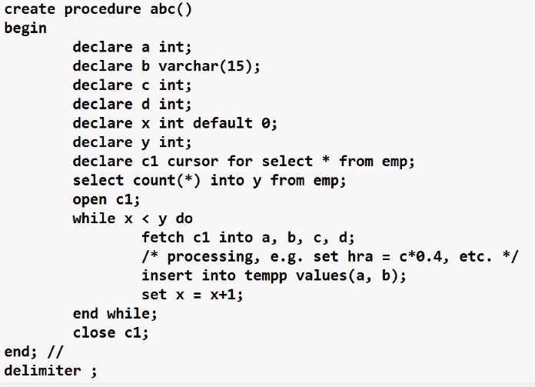

After running while loop 1st time

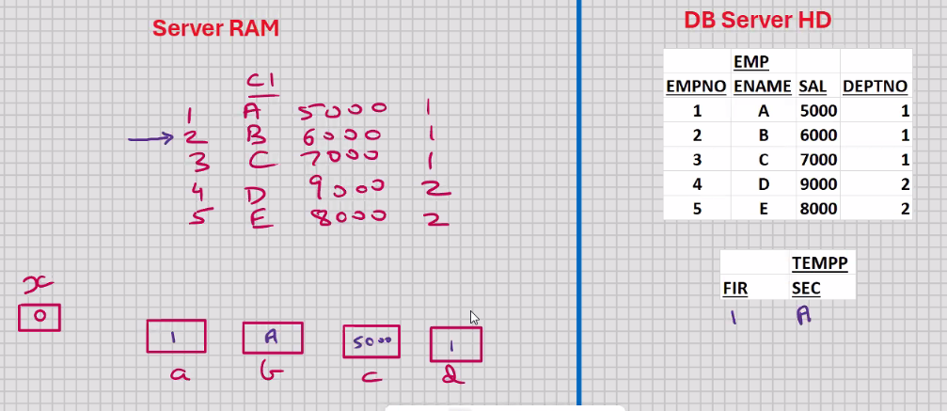

After all the iterations of while loop are completed

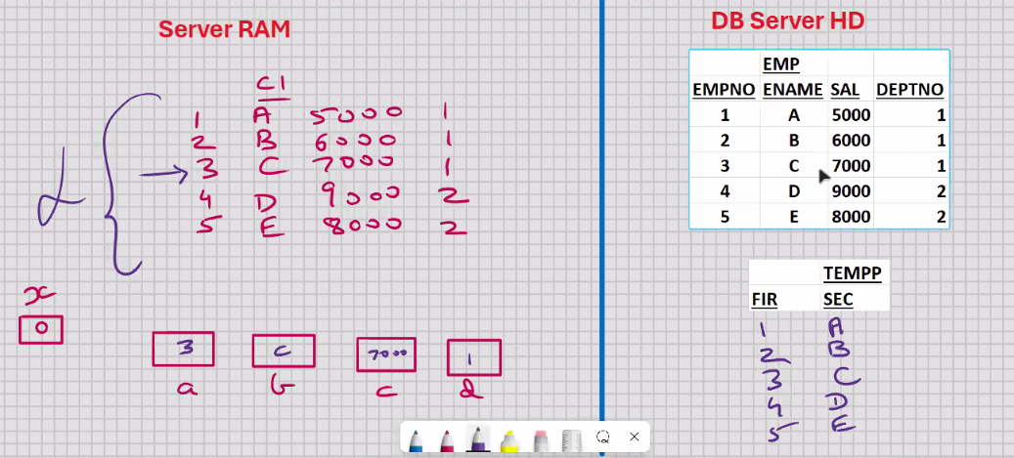

* Declare a CONTINUE HANDLER for NOT FOUND event
* NOT FOUND is a cursor attribute; it returns a Boolean TRUE value if the last fetch was unsuccessful, and FALSE value if the last fetch was successful

Delimiter //

Create procedure abc()

Begin

Declare a int;

Declare b varchar(15);

Declare c int;

Declare d int;

Declare y int default 0;

Declare c1 cursor for select * from emp; <- cursor declaration/ definition (at this point cursor doesn’t contain any data)

Declare continue handler for not found set y= 1;

Open c1; <- it will open the cursor c1, it will execute the select statement, and it will populate the cursor c1

Cursor_c1_loop:loop

Fetch c1 into a, b, c, d; <- fetches the next row

If y = 1 then

Leave cursor_c1_loop;

End if;

/* processing e.g. hra = sal*0.4 , etc.

Insert into tempp values(a, b);

End loop cursor_c1_loop;

Close c1; 🡨this will close the cursor c1 and free the ram

End; //

Delimiter ;

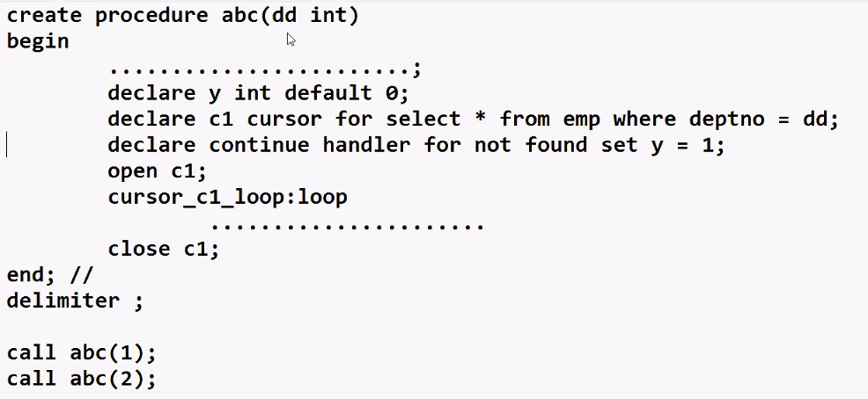

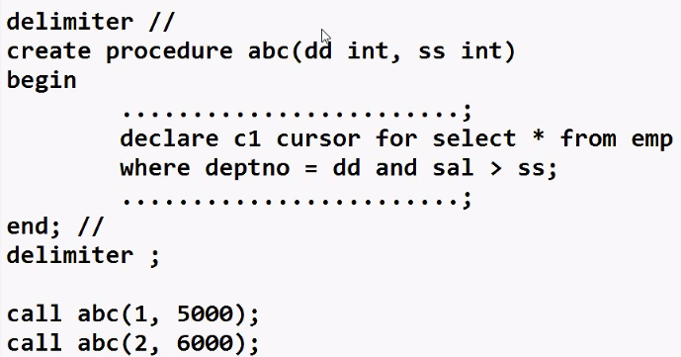

Use of cursors :-

1. Used for storing/ processing multiple rows
2. USED FOR LOCKING THE ROWS MANUALLY

Mysql > select * from emp for update; 🡨 this will manually lock all the rows in backend (this is half the correct answer we need to create cursor for manually locking the table like below)

Delimiter //

Create procedure abc()

begin

declare c1 cursor for select * from emp

where ................ for update;

for update;

Open c1;

Close c1;

End; //

Delimiter ;

Mysql > call abc();

* If you want to lock the rows manually :-
* Locks are automatically released when you rollback or commit
* If you want to lock specific rows only use where clause
* You can pass parameters to a procedure

**Parameters are of 3 types :-**

**IN (by default)**

--

**\* Read only**

**\* while working with in you can pass a constant, variable, and expression**

**\* call by value**

Delimiter //

Create procedure abc( y int ) 🡨 int type because it is only read only

Begin

Insert into tempp values(y , ‘inside abc‘);

End; //

Delimiter ;

---------------------------------

Delimiter //

Create procedure pqr()

Begin

Declare x int default 10;

Call abc(5);

Call abc(x);

call abc(2*x+5);

end; //

delimiter ;

-------------------------

Call pqr();

OUT

-------

* write only

INOUT

----------

* read and write

MYSQL – PL

STORED OBJECTS

* Objects that are stored in the database
* E.g. CREATE .... tables, indexes, views, stored procedures
* Anything that you do with CREATE command is a stored object

STORED FUNCTIONS –

* Routine that returns a value directly and compulsorily
* Global functions
* Stored in the database
* Can be called in MySQL command line client, MySQL workbench, java, MS .NET, etc.; can be called through any front-end s/w
* Stored in the database in the COMPILED FORMAT
* Hence the execution will be very fast
* Hiding the source code from the end user
* Within the function, all MYSQL -PL statements allowed , e.g. variables, cursors, IF Statement, sub-blocks, loops etc.
* Stored procedure can call stored function
* Stored function can call another function
* Function can call itself (known as Recursion)
* To make it flexible, you can pass parameters to a function
* OVERLOADING of STORED FUNCTION IS NOT ALLOWED, because it’s a stored object; you can’t create 2 or more functions with the same name even if the NUMBER of parameters passed is different or the DATATYPE of parameters passed is different
* IN parameters are allowed ONLY

Stored functions are of 2 types :-

1. Deterministic
2. Non deterministic

* For the same input parameters, if the sored function returns the same result, it is considered deterministic, and otherwise the sored function is not deterministic
* You have to decide whether a stored function is deterministic or not
* If you declare it incorrectly , the stored function may produce an unexpected result, or the available optimization is not used which degrades the performance

Mysql > call abc();

* Unlike a stored procedure a stored function cannot be called by itself, because a function returns a value and that value has to be stored somewhere, and therefore the function has to be equated with a variable, or it has to be a part of some expression

Code for function :_

Delimiter //

Create function abc() 🡨 function name

Returns int

Deterministic

Begin

Return 10;

End; //

Delimiter ;

* Read , compile, plan, and store it in the DB in the COMPILED FORMAT

Function created.

--------------------------------------------------

Calling program :-

Delimiter //

Create procedure pqr()

Begin

Declare x int;

Set x = abc();

Insert into tempp values (x, ‘after abc’);

End; //

Delimiter ;

Mysql > call pqr();

To drop the function :-

Drop function abc;

Example :-

Delimiter //

Create function abc (y int)

Returns int

Deterministic

Begin

Return y*y;

End; //

Delimiter ;

------------------------------------------------

Delimiter //

Create procedure pqr()

Begin

Declare x int;

Set x = abc(10);

Insert into tempp values (x, ‘after abc’);

End; //

Delimiter ;

----------------------------

Mysql > call pqr();

Question :- 1.practical use of cursor

1. What is the difference between stored procedure and stored function
2. What is the similarity between stored procedure and stored function

**VVV IMP :-**

* **Stored function can be called in select statement**

Mysql > select abc(sal) from emp;

* It will return the square of sal value
* **Stored function can be called in DML commands also**

Mysql > update emp set sal = abc(sal);

Mysql > delete from emp where abc(sal) = 1000000;

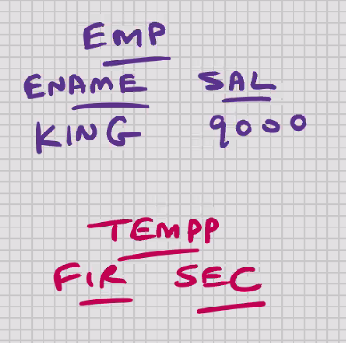

Delimiter //

Create function abc (y int)

Returns Boolean

Deterministic

Begin

If y > 5000 then

Return TRUE;

Else

Return FALSE:

End if;

End; //

Delimiter ;

==================================

Delimiter //

Create procedure pqr ()

Begin

Declare x int;

Select sal into x from emp where ename = ‘KING’;

If abc(x) then

Insert into tempp values (x, ‘> 5000’);

Else

Insert into tempp values (x, ‘<= 5000’);

End if;

End; //

Delimiter ;

===================

Mysql > call pqr();

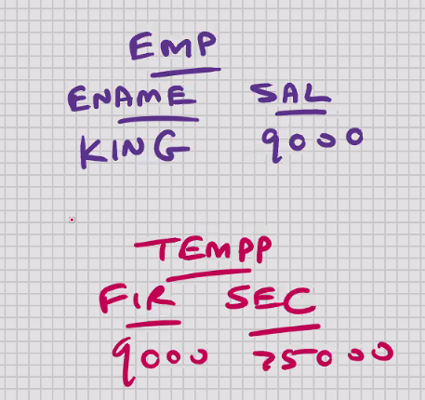

* Function is normally used as a validation routine
* Function normally returns a Boolean TRUE or FALSE value, accordingly some future processing
* If function returns a Boolean value, then you can directly use the function name as a condition for IF statement

To see which all functions are created :-

Show function status; 🡨 shows all functions in all databases

Show function status where db = ‘cdacmumbai’;

Show function status where name like ‘a%’;

To view the source code of stored function :-

Show create function abc;

To share the function with other users :-

Root_mysql > Grant execute on function cdacmumbai.abc to scott@localhost;

Scott_mysql > select cdacmumbai.abc() from dual;

Root_mysql > revoke execute on function cdacmumbai.abc from scott@localhost;

* Objects that are stored in the database
* CREATE ....... tables, indexes, views, stored procedures, stored functions
* Anything that you do with CREATE command is a stored object

**MYSQL – DATABASE TRIGGERS (V.IMP) :-**

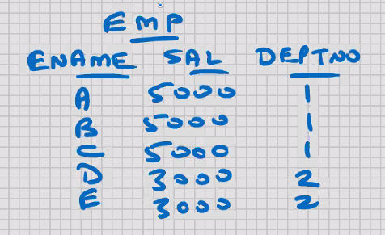 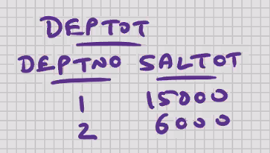



* Present in some of the RDBMS
* Routine (set of commands) that gets executed automatically whenever some event takes place
* Triggers are written on tables
* Events are :-
  + Before Insert, after insert
  + Before delete. After delete
  + Before update, after update
* In mysql , all triggers are at row level (will fire once for each row)
* In mysql , you can have maximum 6

Delimiter //

Create trigger abc

Before insert

On emp for each row

Begin

Insert into tempp values(1, ‘inserted’, user(), sysdate(), now(), etc.);

End; //

Delimiter ;

--🡪 READ , Compile , plan , and store it in the DB in the COMPILED FORMAT

Trigger created.

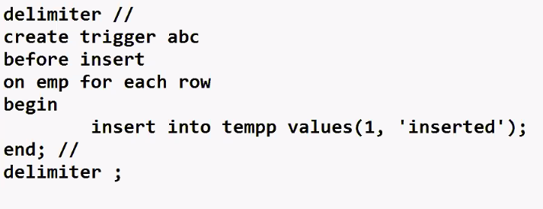

* If INSERT operation on table fails, then it will cause the event to fail, and the triggers changes are automatically rolled back
* If the triggers fails , it will cause the event to fail, and the INSERT operation on table is automatically rolled back
* YOUR DATA WILL ALWAYS BE CONSISTENT

USES :-

* Maintain logs (audit trails) of insertions
* AFTER INSERT triggers is recommended

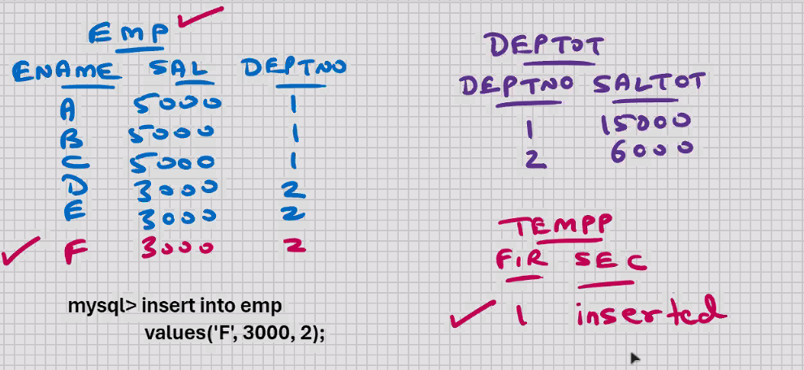

* Within the trigger, all MYSQL- PL statements allowed, e.g. variables, cursors, IF statements, loops, sub-blocks, etc.
* Whether you rollback or commit AFTERWARDS , the data will always be consistent
* Rollback and commit not allowed inside the trigger
* Rollback or commit has to be specified AFTERWARDS, at the end of transaction
* Whether you rollback or commit AFTERWARDS, the data will always be consistent
* Triggers allows either everything is committed or nothing is committed.



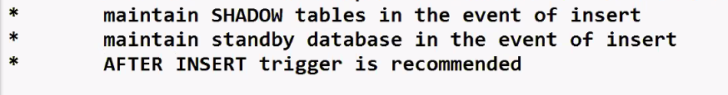

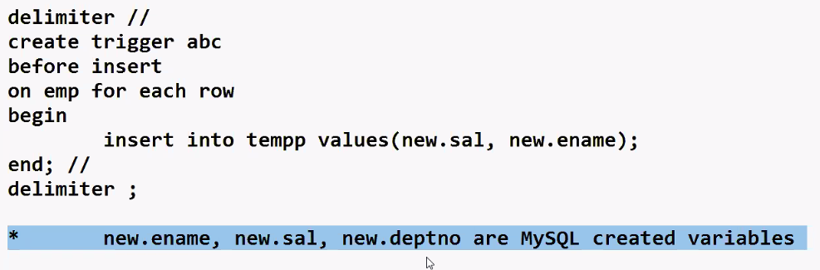

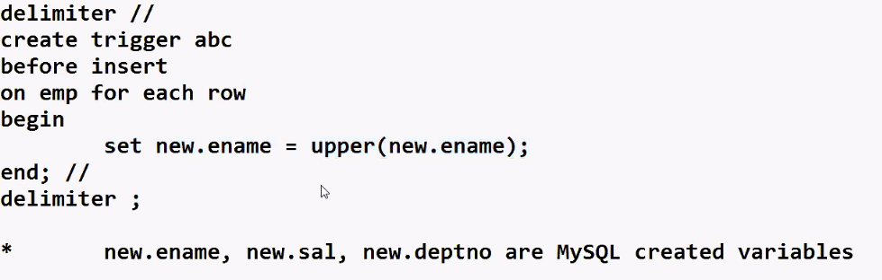

Uses :-

* The above concept is called DATA cleansing
* Data cleansing BEFORE INSERT

Updating the deptot table

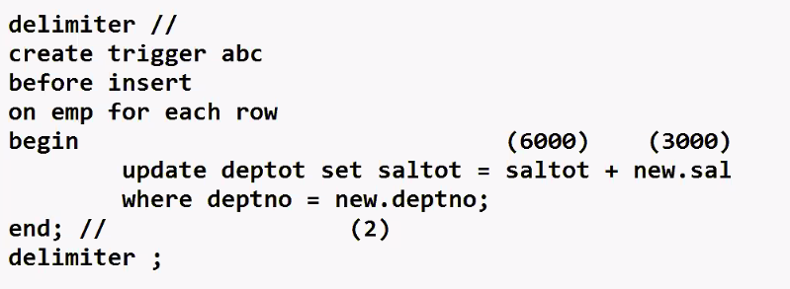

Uses : -

* Auto – updation of related tables

AFTER INSERT trigger is recommended

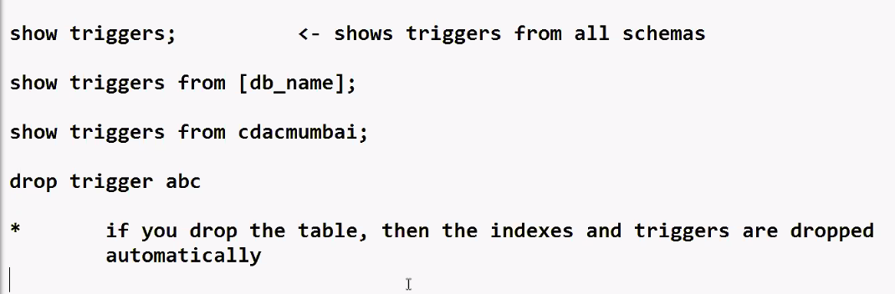

To get more detailed information about triggers :-

Select * from information_schema.triggers

Where trigger_schema = ‘cdacmumbai’;





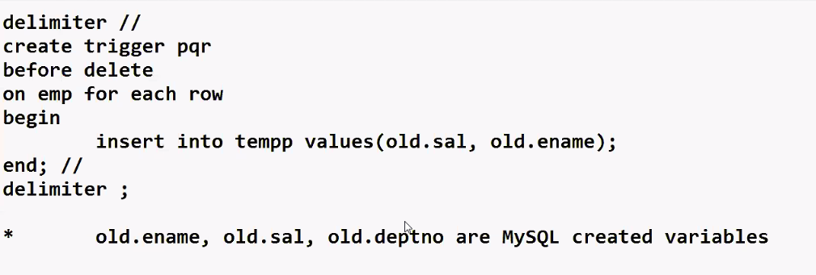

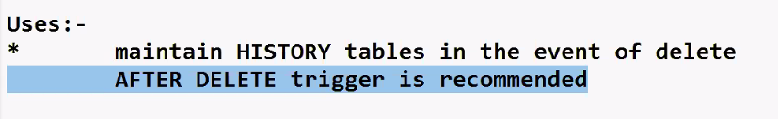



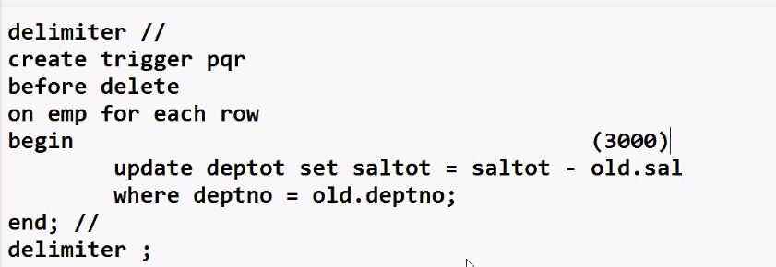

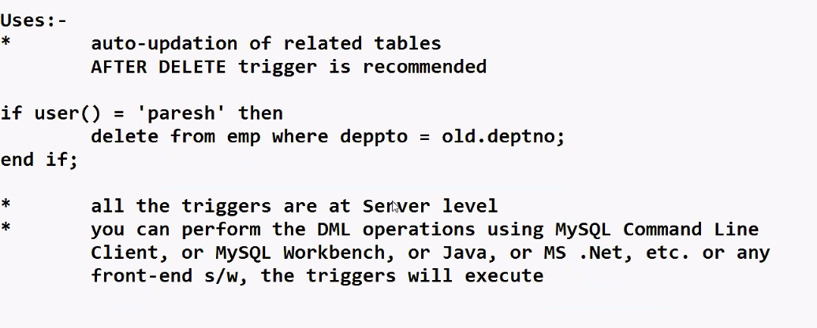

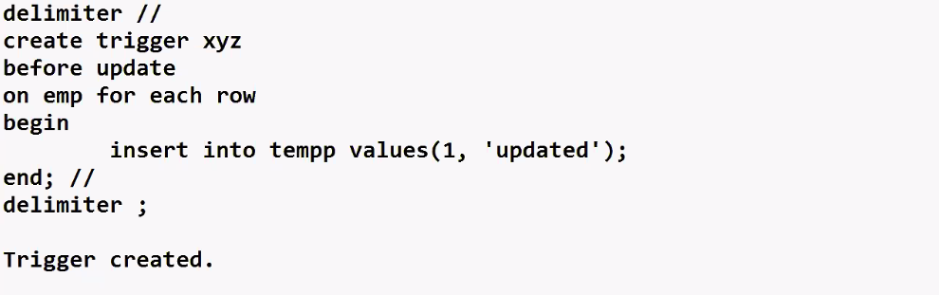

Uses :-

* Maintain logs (audit trails) of updations

AFTER UPDATE triggers is recommended

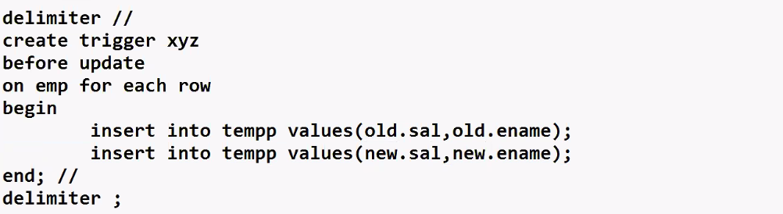

* Old.ename, old.sal, old.deptno, new.ename, new.sal, new.deptno are MySQL created variables

Uses :-

* Maintain SHADOW and HISTORY tables in the event of update

AFTER UPDATE trigger is recommended

Cascading triggers 🡪 one trigger causes a second trigger to execute, which in turn causes a third trigger to execute, and so on

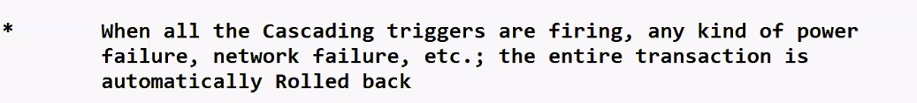

* Mutating table error -> if some cascading trigger causes one of the previous triggers to execute, then it will not go into infinite loop; you will get an error that the table is undergoing mutation and the entire transaction is automatically rolled back

Example 3 :-

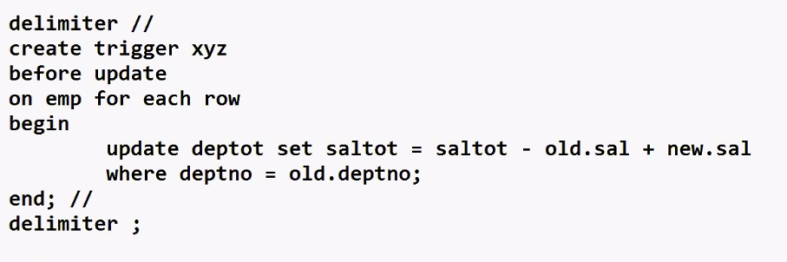

Example 4 :-

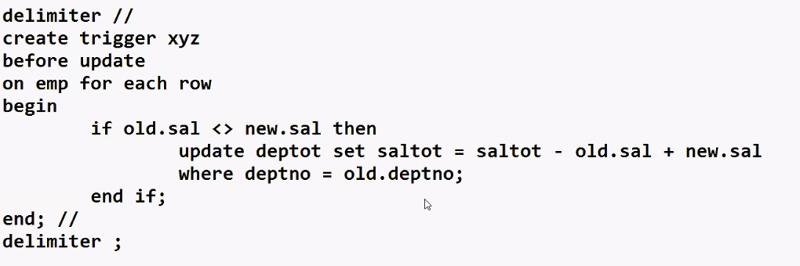

Example 5 :-

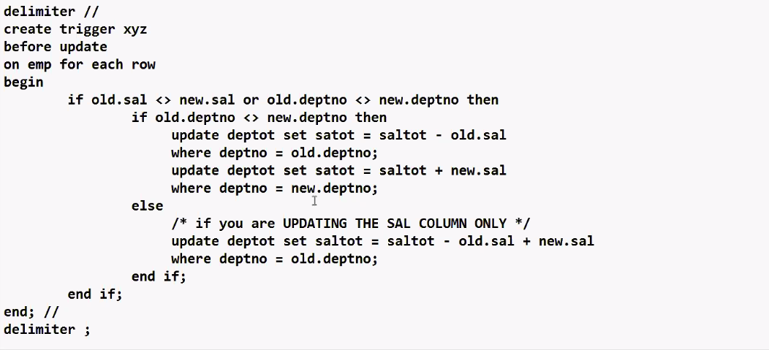

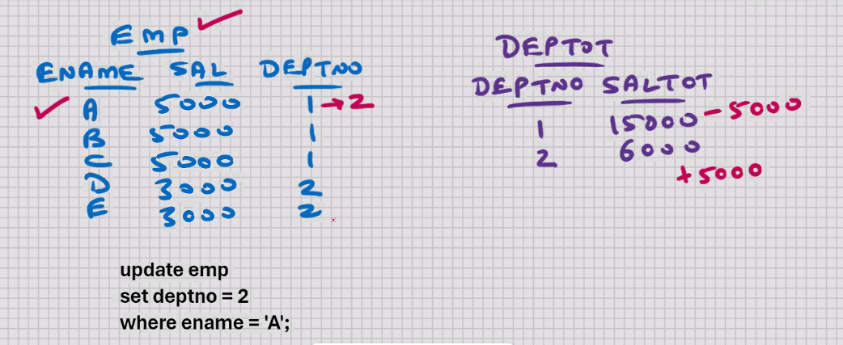

MYSQL – NORMALISATION :-

* Applicable for RDBMS (e.g. MySQL) and ORDBMS (e.g. Oracle)
* Concept of table design
* RDBMS 🡪 1st to 4th Normal Form
* ORDBMS 🡪 1st to 9th Normal Form
* What tables to create, structures, columns, datatypes, widths, constraints
* Based on user requirements
* Part of design phase (min 1/6) coding (25% - 33%)
* Aim of normalisation is to have an “efficient” table structure
* Aim of normalisation is to avoid the data redundancy (avoid the unnecessary duplication of data)
* Secondary aim of normalisation is to reduce the problems of insert, update, and delete
* Normalisation id done from an input perspective
* Normalisation is done from a Forms perspective
* VIEW the entire application on a per-transaction basis, and you normalise each transaction separately

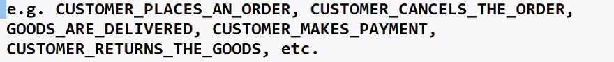

CUSTOMER_PLACES_AN_ORDER

Getting ready for normalisation

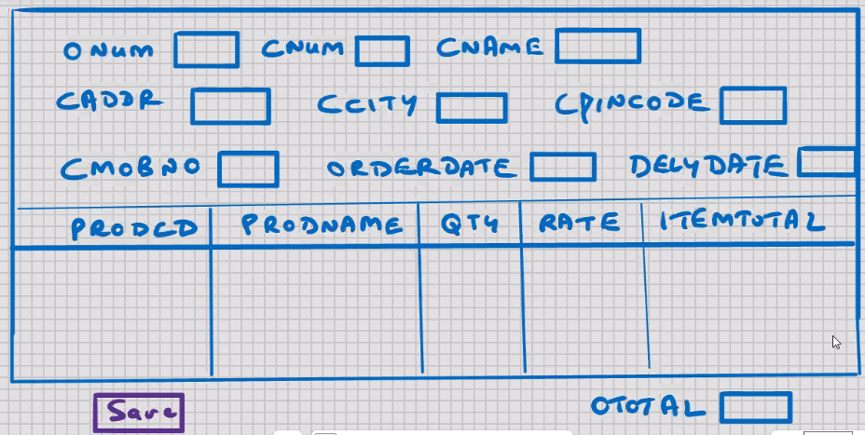

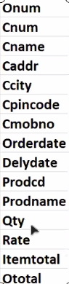

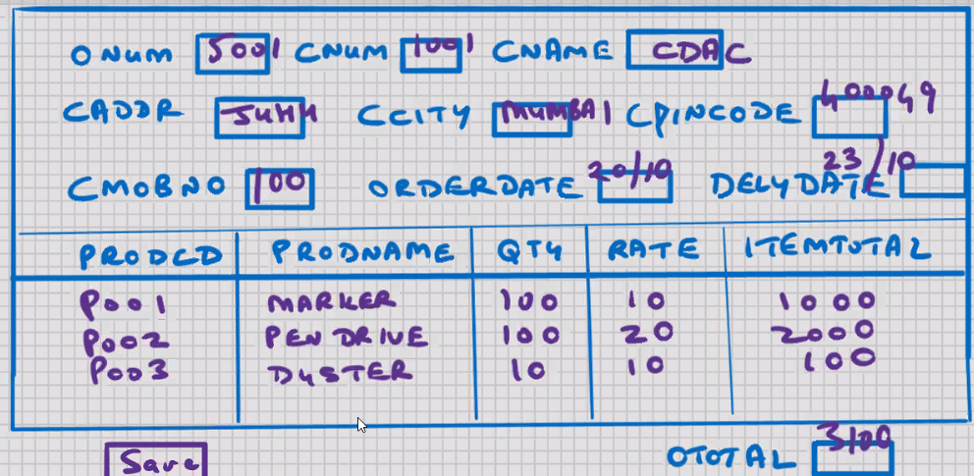

1. For a given transaction, make a list of fields
2. Ask the client for some sample data
3. With the permission and involvement of client, strive for atomicity (column is divided into sub-columns, and sub-columns are divided into sub-sub-columns)
4. For every column, make a list of column properties
5. Get client sign -off
6. End of client interaction
7. Assign the datatype for each column
8. Assign the width for each column
9. Assign the not null, unique, and check constraints
10. For all practical purposes, you can have a single table with all these columns
11. Remove the computed columns (e.g. itemtotal , ototal)

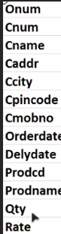 Item total = qty*rate

Order total = sum (qty*rate)

1. Key element will be primary key of this table

* At this point, the data is in Un-Normalised form (UNF)
* Un-Normalised form 🡪 starting point of normalisation

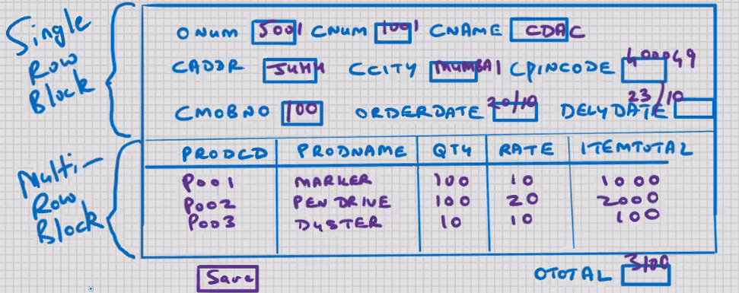

1. Remove the repeating group into a new table

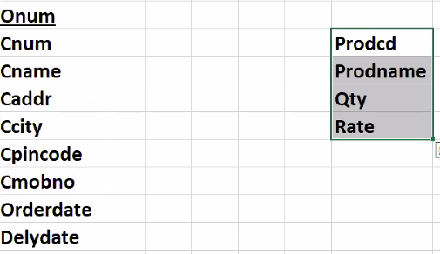

1. Key element will be the primary key of new table
2. (This step may or may not be required) add the primary key of the original table to the new table to give you a composite primary key

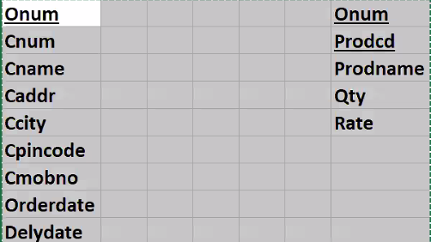

* The above 3 steps are to be repeated infinitely till you cannot normalise any further

**FIRST NORMAL FORM (FNF) (Single Normal Form) (1NF) 🡪**

**Repeating groups are removed from table design**

* **1 : Many relationship is always encountered here**
* **DEPT and EMP tables are in First Normal Form**

**25% cases are done here**

1. Only the tables with composite primary key are examined
2. Those non – key elements that are not dependent on the entire composite primary key, they are to be removed into a new table

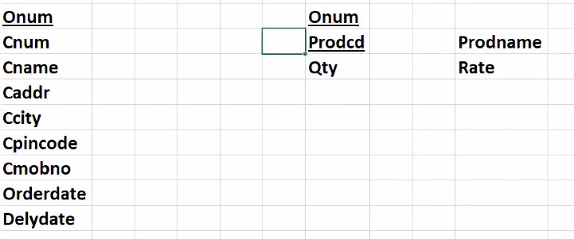

1. Key element on which originally dependent, it is to be added to the new table, and it will be the primary key of the new table

* Above 3 steps are to be repeated infinitely till you cannot normalise any further

**SECOND NORMAL FORM (SNF) (Double Normal Form) (2NF)**🡪

**Every column is functionally dependent on primary key (Functional Dependency)** 🡪 **without primary key, that column cannot function**

**67% cases are done here**

1. Only the non – key elements are examined for inter-dependencies
2. Inter-dependent columns are to be removed into a new table

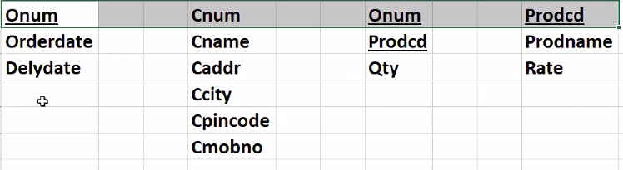

1. Key element will be primary key of the new table, and the primary key of new table, that column, it is to be retained in the original table relationship purposes

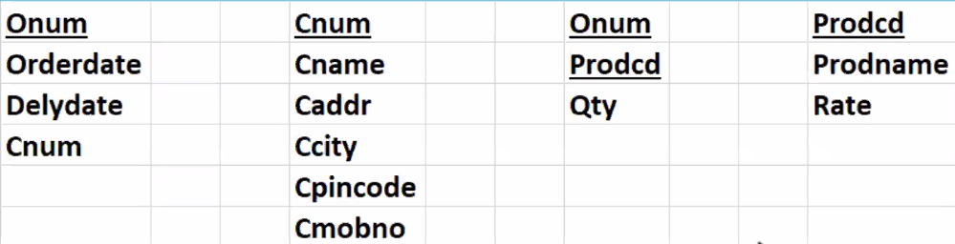

* These 4 tables are needed when customers place an order
* Above 3 steps are to be repeated infinitely till you cannot normalise any further

**THIRD NORMAL FORM (TNF) (Triple Normal Form) (3NF) 🡪**

**Transitive dependencies (inter - dependencies) are removed from table design**

Giving suitable names to the tables :-

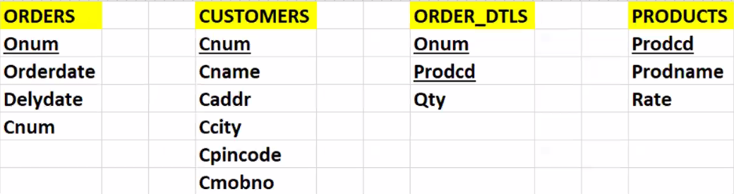

* Primary key is a by – product of Normalisation

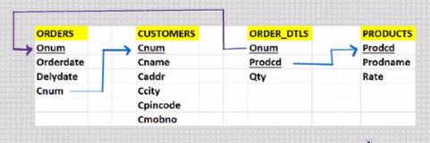

Diagram showing foreign keys

**Post Normalisation**

* Implement Extension columns

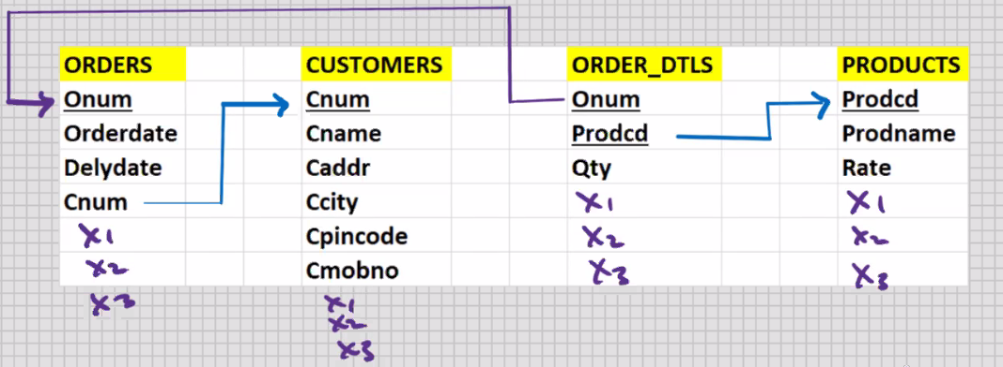

* Reserve some columns for logs of DML operations

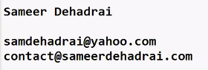

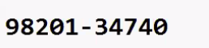

1.Create table

2. insert

3. select 5 -10

4. stored procedure

5. stored function